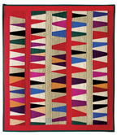
Gwen Marston Workshop March 24 – 26, 2017
Abstract Quilts in Solids
Abstract Quilts in Solids materials list.
Sewing machine and basic sewing machine tools. Rotary cutter, mat and rulers. (a 6"X12", or 6"X24" is suggested)
Fabric: You can work with predominantly lights, mid-tones or darks. You can work with bright colors or dull colors. Regardless of your predominant tone, include some accent colors. Bring color ideas you like to work with.
Fabric amount: (This is a 3-day workshop and the following are Gwen’s general guidelines) For a 2 day class bring a total of 3 yards of fabric, and for a 4 or 5 day class, bring a total of 5 yards. (These are approximate amounts of fabric. You know how you like to sew, and how much fabric you like to have available).

Do a little homework and come to class with some ideas. Also, for color and design ideas look through some of Gwen's books that include work in solids:
-Ideas and Inspirations: Abstract Quilts in Solids, 2010 (order from Lulu.com)
-37 Sketches, 2011 (order from gwenmarston.com)
-Liberated Quiltmaking II (AQS 2009)
-Liberated Medallion Quilts, (AQS 2012)
-Minimal Quiltmaking (AQS 2014)

Meet Gwen:

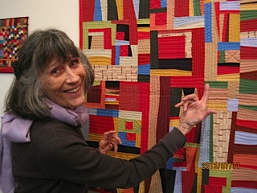
Gwen Marston is a professional fiber artist, author, and teacher. She has taught nationally and internationally for over three decades. She has written 26 books, two of which have won awards: Mary Schafer: American Quilt Maker won a 2005 Michigan Notable Book award, and 37 Sketches won a 2012 New York Book Show award.
She has had nineteen solo exhibits, seven exhibits of her small quilts, seven exhibits of her collaborative work with Freddy Moran and her work has been shown in thirty-five invitational exhibits throughout the United States and abroad. For thirty years Gwen offered a series of quilting retreats in the fall of the year for serious students of quiltmaking. She lives and works on Beaver Island, MI.

